Updating Raspberry Pi
- Clone the repository from to your local machine: https://github.com/Adambots-245/Pi-2022 . On the driver station laptop, I have already cloned it to the Pi-2022 folder on the desktop.
- Connect to the Robot via Wi-Fi
- Open this folder in VSCode and build it. There are two ways to build it:
- Option 1:
  - Run “Build Robot Code” from the Command Palette and choose “Java” as the option.
- Option 2:
  - Open a terminal window (Ctrl + `) – that is Ctrl + Backtick (same as ~ key).
  - Run “./gradlew build”
- Once the build is successful, locate the “Pi-2022-all.jar” in this folder: Pi-2022/build/libs/
- Go to the Raspberry Pi’s web interface: http://wpilibpi.local/
- Set the Pi to “Writable” mode:
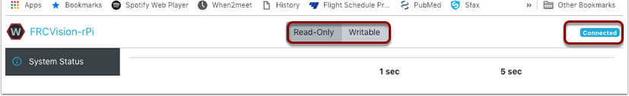
- Go to the “Application Tab”, choose the “Pi-2022-all.jar” file and upload it:
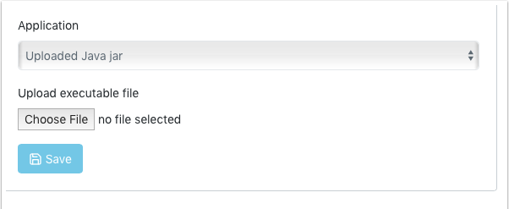
- This will update the running application. Check the status, by switching to the “Vision Status” and enabling the console output:
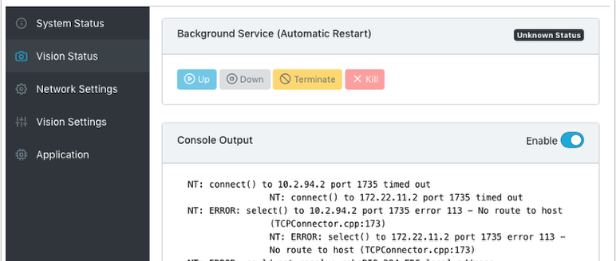

Updating the GRIP Pipeline via Pi

- Connect to the Robot via Wi-Fi
- Open GRIP and load the GRIP file from the following folder: In the main repository /src/main/java/frc/robot/vision. The latest GRIP file is named RefelctiveTape-States.grip.
- GRIP extracts one frame at a time from the video and then processes it via a pipeline of tasks. The GRIP window at the bottom shows the full pipeline of image processing that are applied. The top window shows the intermediate images at each stage. Click on the “Eye” icon to preview the image.
- Delete the current source and add a “IP Camera” source. For the IP Camera address enter the following:
  - http://wpilibpi.local:1181?action=stream
  - 1181 is the default port, but may need adjustment if it does not work
- Connect the source image to the first Pipeline task (as shown in step 4, below):

- Tune the GRIP pipeline until the filtered targets look clean.
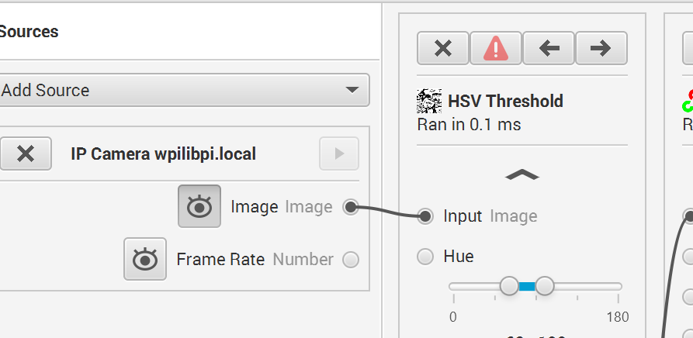
- Once the tuning is complete, generate the Java code, by Tools -> Generate Code:
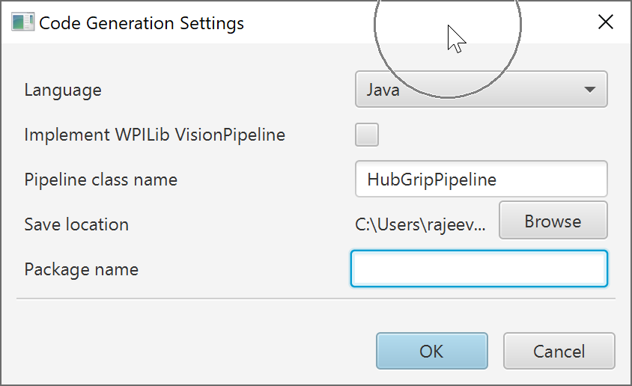
- Leave the Package Name empty and do NOT check the VisionPipeline checkbox. Save this file to this path: Pi-2022/src/main/java/HubGripPipeline.java
- Open the Pi-2022 project, build and then deploy it to Pi.

